**Module 04**

1. **What is priority?**

* Priority is defined as the order in which a defect should be fixed. Higher the priority the sooner the defect should be resolved.
* Defects that leave the software system unusable are given higher priority over defects that cause a small functionality of the software to fail.

**Priority of Types :-**

**Low:**

* The Defect is an irritant but repair can be done once the more serious Defect has been fixed.

**Medium:**

* During the normal course of the development activities, defects should be resolved. It can wait until a new version is created.

**High:**

* The defect must be resolved as soon as possible as it affects the system severely and cannot be used until it is fixed.

1. **What is severity?**

* Severity is defined as the extent to which a particular defect can create an impact on the software. Severity is a parameter to denote the implication and the impact of the defect on the functionality of the software.

**Types of Severity :-**

**Critical:**

* This defect indicates complete shut-down of the process, nothing can proceed further.

**Major:**

* It is a highly severe defect and collapses the system. However, certain parts of the system remain functional.

**Medium:**

* It causes some undesirable behavior, but the system is still functional.

**Low:**

* It won’t cause any major break-down of the system.

1. **Bug categories are…**

* A software bug is a problem, failure, error, or fault that results in a computer or software system crashing or failing.
* A software bug is a flaw, error, or fault in a computer system or program that causes it to perform incorrectly or unexpectedly or produce unintended results.
* Software bugs are divided into three board categories, under which we have several types of bugs. Bugs are classified by-

1) Nature.

2) Priority.

3) Severity.

1. **Advantage of Bugzilla.**

* it is an open-source widely used bug tracker;
* it is easy in usage and its user interface is understandable for people without technical knowledge;
* it easily integrates with test management instruments;
* it integrates with an e-mailing system;
* it automates documentation.

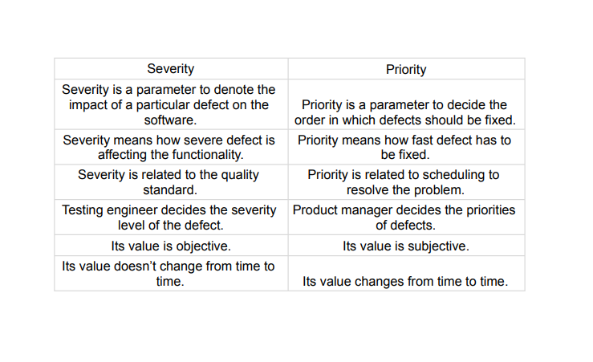

1. **Difference between priority and severity.**